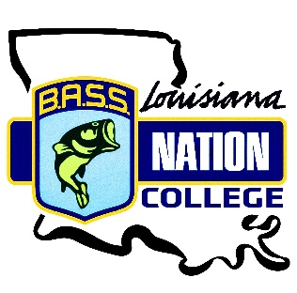

2021 LBN Championship
Jimmie Davis State Park, Caney Lake
Sunday, March 14th 2021

Please read this in its entirety. If you know teams that are not on Facebook, make sure they have this information to avoid issues.

Friday, March 12th is your official practice day, and all rules are in place. If you choose to pre-fish on Saturday, do not launch from Jimmie Davis State Park because it will be full of high school teams. Also, you must yield the water to high school teams on Saturday if you are in an area that they are in.

We will start boat checks/ check in between at 4:30am Sunday morning in the area shown on the attached maps, at the north launch.

As soon as you stop in the line to the boat check, start prepping your boat for inspection. Do not wait until you get to officials to prep your boat or there may be a penalty assessed.

North Launch for Launch, blast off, and check-in. Weigh in area will shown on maps on the pre-tournament document.

Items to be completed before you get to boat check are:

- Navigation lights in and turned on. You will not be allowed to fish if your lights aren’t working.

- Livewells open for inspection.

- One PFD for each member of the team, on the deck, easily visible to tournament officials.

- You may be spot checked for insurance papers, be prepared to show them. Boat number one will be checked for proof of insurance. Be prepared.

- Double check to make sure that your plug is in while prepping.

- *When you get within 1/8 mile of the check in station, send one team member to the check in table to check in and get Check in Card. Make sure that they know their boat number.

- Kill Switch visible and working. You will be required to pull it at take off.

- When approaching ramp area, please turn your headlights off to avoid blinding those trying to back boats and directing traffic.

You may motor from the other areas at a “reasonable” distance but use extreme caution navigating and go slowly. For those arriving via water, boat checks will be done at the dock at the north launch.

Also, if coming to the launch via water, it is your responsibility to get your boat checked, check in, and get your ribbon and card.

After launching boats, drivers, proceed immediately to the parking areas. Please be considerate and avoid getting in a position that would impede traffic flow.

Do not park your boat on the docks and hang out. Only use the docks for entering and exiting boats as well as getting boat checks. This is a courtesy to those needing to get to their boats and we will monitor this.

Have angler motor away from launches to wait until the driver returns for pickup.

The first flight is due in at 3:00. If your Check in Card is not in the hands of tournament officials before your due in time, you are late. There will be someone checking boats in that afternoon at the North launch Dock, please find them before your check in time. Late penalties will be assessed if late.

We will go by BASS’ rules for late penalty. 1 pound per minute late, up to 15 minutes and then DQ’d. Check in official’s time is final.

Tournament waters are public waters of the Caney Lake No fishing within 200 yards of the host landing (Fishing within 200 yds of both north and south launches is prohibited)

Flight check in times

Flight 1: 3:00pm Boats 1 through 20
Flight 2: 3:15pm Boats 21 through 40

Very important!! Do not stop in the parking area to strap your boat unless you pull into a parking spot. When entering or exiting the launch areas make sure to pull to the left lane and leave room for tow vehicles to pass on your right.

DO NOT BLOCK THE ENTRANCE/ EXIT TO A LAUNCH, BE COURTEOUS AND WAIT UNTIL YOU CAN PULL BOTH TRUCK AND TRAILER COMPLETELY OUT OF THE FLOW OF TRAFFIC BEFORE YOU MOVE FORWARD!

To minimize the time that your fish are in the weigh bag and ensure fish care, you are required to use our tournament bags with mesh inserts. Upon arriving at the weigh-in area, send one angler to the bump station to retrieve one of our bags then return to get the team’s catch. If you bring fish to the bump station in a bag other than our official bags, it may result in a ¼ pound penalty.

Photos will be taken in a photo area only. Family may take photos as well.

We ask that every angler read and understand the rules document. Most of the many questions that we are asked come directly off the rules document. You need to keep a copy of the rules in the boat for reference.

The minimum length for bass on Caney Lake will be 12”

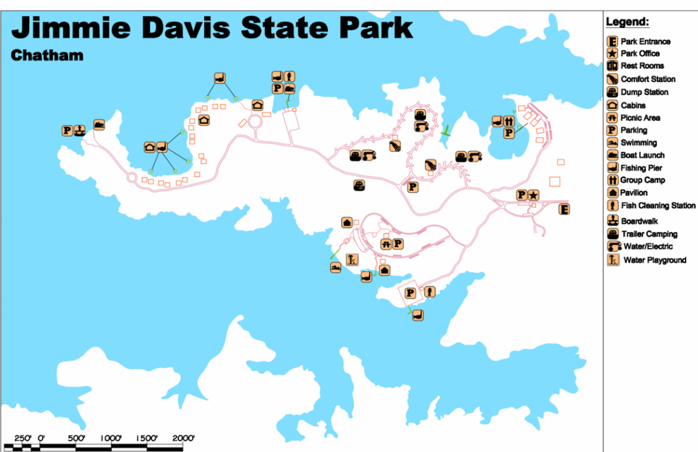

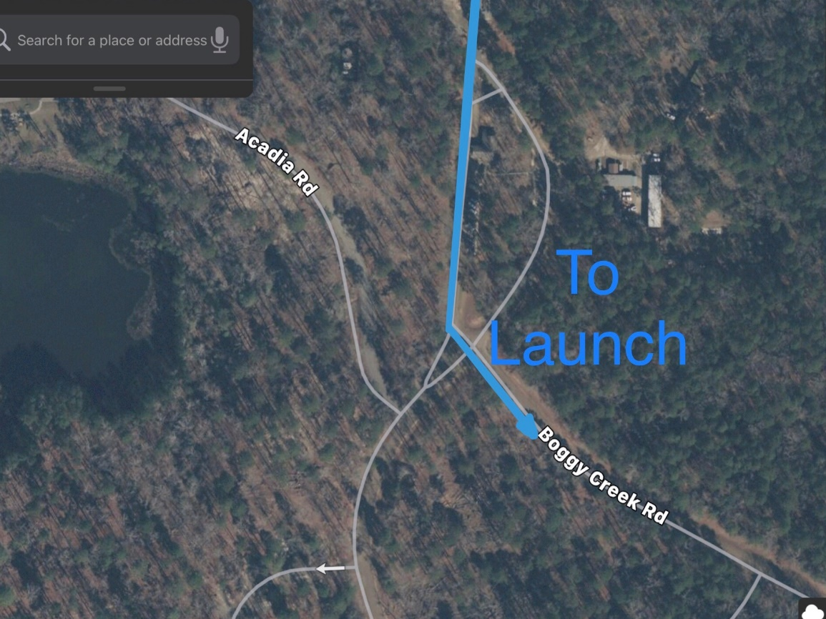

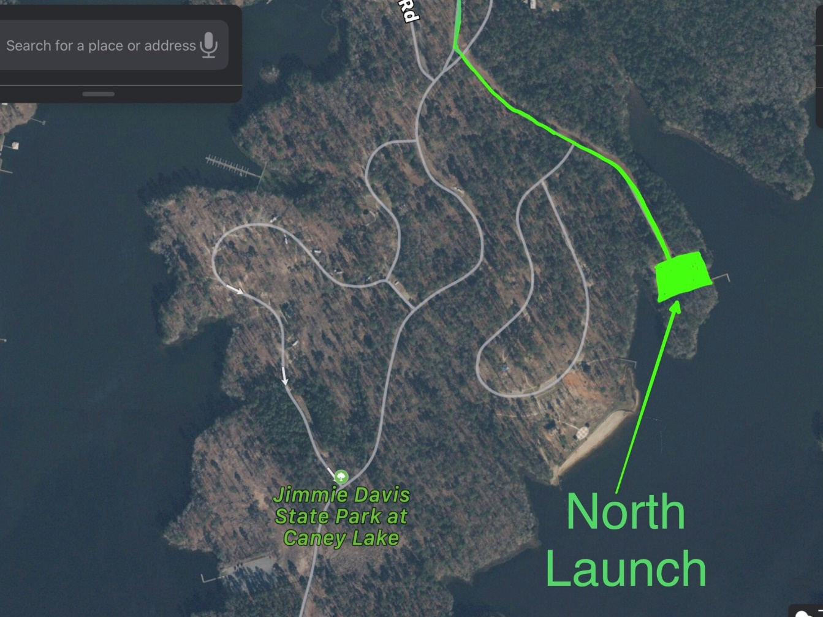

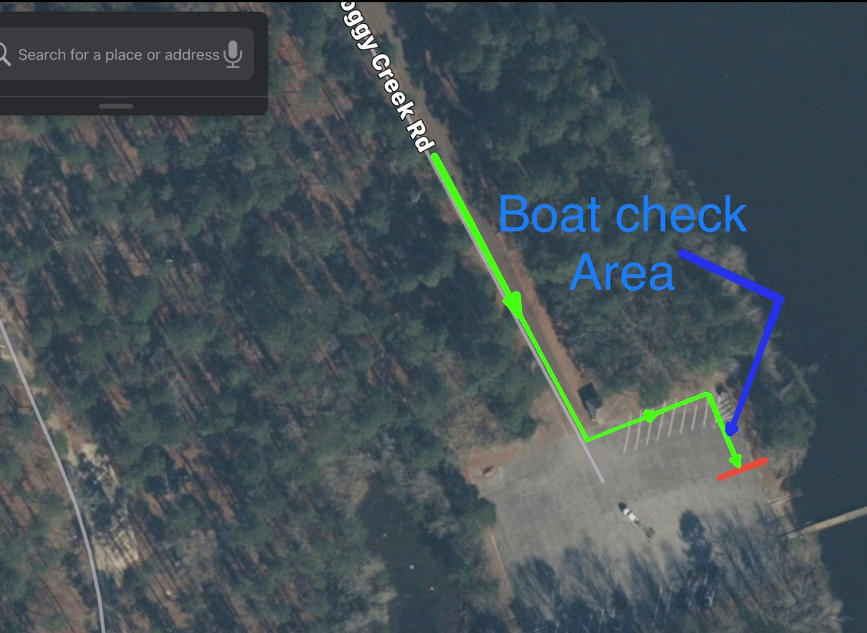

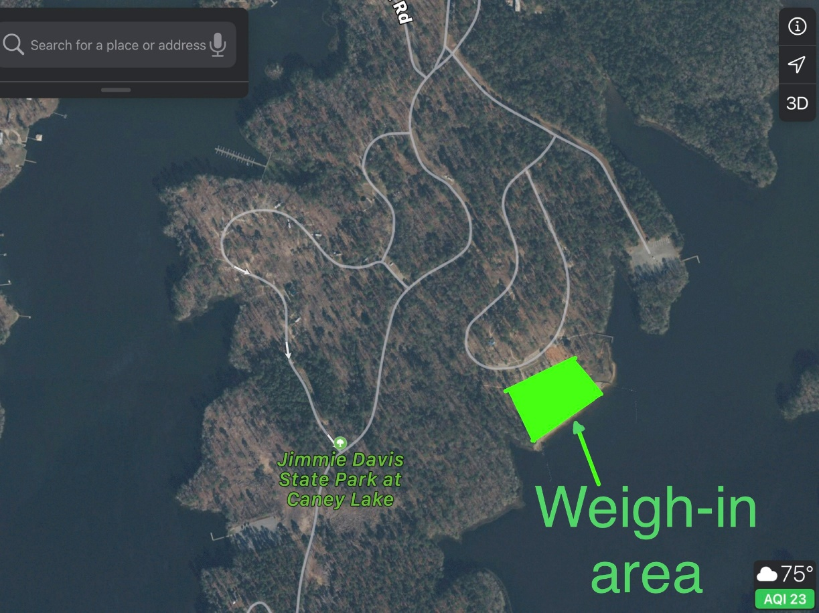

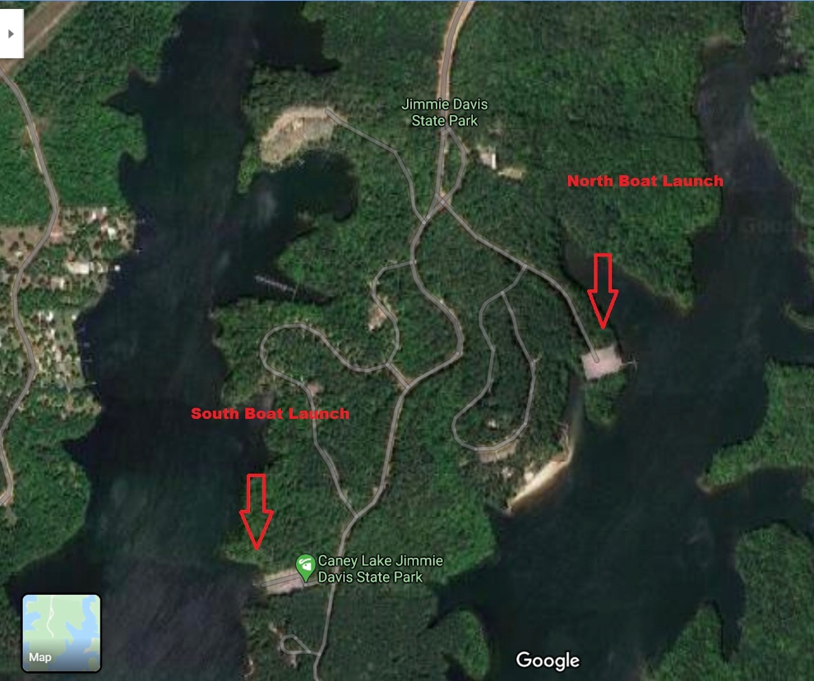

Be courteous in the parking/ Launch area. If someone needs to back out, try to let them out.

As always, be courteous to non-tournament boaters. Be aware of where other teams are fishing and what direction that they are heading so you don’t cut their fishing path off. Slow to an idle, no wake, when passing within 50 yards of another boat.

If you are headed to within 25 yards of another boat, please get permission to go by, but once again, do not pass and cut of their fishing direction. If they are in a confined area and do not give permission, please do not pass them.

Verbal or physical confrontations break the BASS code of conduct and are grounds for disqualification. Report immediately, via text, to tournament officials if a violation occurs.

College anglers when you are on the lake pre-fishing on Saturday, please yield the water to high school teams.
(This is their tournament day

